“Sustainable Beauty”,

Neolith’s Forward-Looking Sustainability Campaign

* **With a firm commitment to building a better world with beautiful living spaces, Neolith is looking to the future by presenting this all-new sustainability campaign as the most environmentally-friendly architectural surface on the market today.**
* **Through an ode to responsible and sustainable beauty, the brand is allegorically taking a decisive attitude towards caring for and doting on the environment and reducing its environmental impact all while creating spaces to be enjoyed.**

**Madrid; March 23, 2023. –** Neolith has just presented its new campaign [**Sustainable Beauty**](https://sustainability.neolith.com/es?utm_source=mediosnacionales&utm_medium=notadeprensa&utm_campaign=NdPsustainablebeautyES). Through an ode to responsible and sustainable beauty, the world’s leading sintered stone brand is looking to the future and towards building a better world through beautiful spaces meant to be lived in while always respecting and caring for the environment and all the professionals in its value chain.

It’s a message and attitude the company wishes to transmit to its employees as well as the entire community of architects, interior decorators and designers. It’s also for the construction sector, which handles its surfaces on a daily basis, retailers, end consumers and, in short, society at large, so that it can come to life through everyone’s efforts. **Welcome to a more sustainable and sensitive world. Welcome to the future**.

**A GLOBAL STRATEGY FOR A POSITIVE CHANGE**

Aware of its responsibility as an industry, Neolith has taken a decisive attitude towards improving the environment, reducing its environmental impact and creating spaces to be enjoyed. And it’s doing so under the concept the campaign is named after, [*Sustainable Beauty*](https://sustainability.neolith.com/es?utm_source=mediosnacionales&utm_medium=notadeprensa&utm_campaign=NdPsustainablebeautyES)*,* which encompasses three fundamental ideas: *Beautiful Environment, Beautiful Creations* and *Beautiful Community.*

***Beautiful Environment*** is a real declaration of principles that emphasizes nature through **recycling, reducing and reusing** to make a positive impact on the planet. With a product that’s so closely connected to the Earth, Neolith aims to highlight the idea of caring for the very raw materials nature provides us.

It’s a clear reflection of the sintered stone brand’s way of being and creating with unique percentages industry-wide including the fact that 100% of the raw materials used for its products are all-natural. What’s more, up to 98% of those same raw materials are recycled, up to 100% of the water used in the production process is recycled and 100% of the electric energy used comes from renewable sources.

***Beautiful Creations*** is another statement being made by Neolith **as it creates cutting-edge architectural pieces in terms of sustainability and innovation** with a well-renowned circular economy model as the first company in the industry to achieve carbon neutral status.

It’s an architectural surface that also helps **create beautiful living spaces** all while setting design trends, inspiring professionals and consumers alike and offering them solutions to turn each space into something unforgettable with an extensive palette of exquisite, timeless colors. Impressive designs with zero limits that evoke sensations through touch like no other.

***Beautiful Community*** is included as part of its manifesto to describe **the brand’s absolute commitment to the planet and the society that lives on it**, always putting people first in spreading awareness, preserving, supporting and informing, thus looking after the entire value chain. Along these lines, one significant milestone underlining Neolith’s philosophy stands out in particular which is having achieved a completely revolutionary figure in using 0% crystalline silica in its new formula. To date, this is the lowest percentage in the industry.

*“Sustainable Beauty is our sustainability manifesto for creating beautiful, livable and enjoyable spaces with Neolith’s sustainable and responsible materials which not only contribute to bringing harmony and wellbeing to homes, retail projects and city architecture. They also help us make the most minimal impact on the environment all while maintaining the utmost commitment to it* *and all the people around us,”* states **José Luis Ramón, CEO of Neolith Group**.

**ALLEGORY TO NATURE**

For more than a decade, Neolith has been creating living spaces with sustainable materials that reflect beauty and harmony. To identify these values in the brand, Neolith has chosen a highly powerful communication symbol: a dragonfly. Considering the beauty of their iridescent bodies and as a bio-indicator of health in aquatic ecosystems, dragonflies are full of positive characteristics. They’ve awed all types of civilizations which have used the image of a dragonfly for all sorts of purposes.

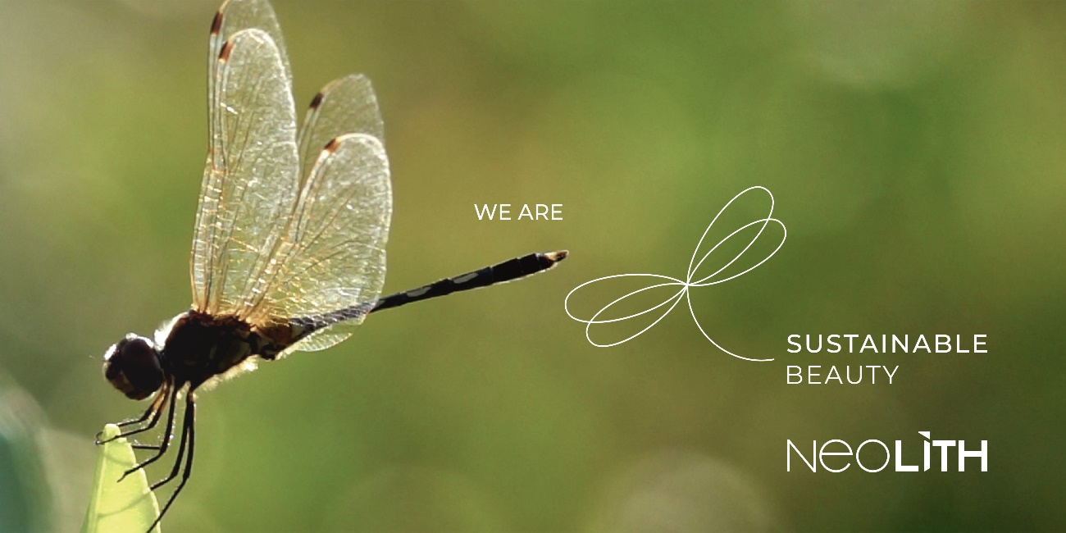

One is now being added to the brand’s iconography through a new visual linear universe linked to its inherent concept of design and functionality, with lines and perspectives taken straight from the construction of the Neolith logotype.

It’s quite the allegory to nature aimed at showcasing an elegant, sophisticated identity embodying the concept of **sustainable beauty**.

About Neolith

Fully believing in the idea that “the best thing about creating something is living it”, Neolith is the global leader in sintered stone. A pioneering architectural surface with superior technical characteristics made of 100% all-natural raw materials, it can provide indoor and outdoor solutions. All around the world, it has become an essential style element for any kitchen, bathroom, facade, floor and even exclusive designer furnishings.

The virtues of Neolith sintered stone combine next-generation technology featuring impressive no-limits designs through its **Iconic Design** line and high functionality. All of that, along with Neolith’s sustainable DNA, have led it to becoming one of the most environmentally-friendly materials on the planet as it advocates **sustainable beauty** in all of its collections to inspire new trends in architecture.

The company is currently immersed in an expansion plan aimed at key geographic areas such as North America, Australia, the UK, Europe and China in order to continue contributing to the creation of unique spaces and extraordinary experiences featuring sustainable functional design in the nearly 100 countries where it is present through direct distribution as well as an extensive sales and partner network.