Neolith presents Iconic Design: the new generation of surfaces featuring the most advanced 3D printing technology

- Neolith Iconic Design is the revolutionary change the sector has been pursuing for years. It’s a whole new generation of surfaces that stands out due to the integrated design for enhanced beauty over the entire volume.

- In line with the product philosophy and brand principles the company’s known for and under three major pillars—design, innovation and sustainability— Neolith is now presenting Iconic Design.

- The unprecedented launch was exclusively presented to its main customers in more than 80 different countries at a private event held a few days ago at the Group’s headquarters.

- This all-new release is the result of two years of work in Neolith’s R&D&I Department in addition to heavy investment of more than three million euros.

Madrid; September 23, 2022.- Neolith has just launched an all-new and revolutionary generation of surfaces featuring 3D printing technology known as Neolith Iconic Design. In line with the product philosophy and brand principles the company’s known for and under three major pillars—design, innovation and sustainability— Neolith is now presenting revolutionary surfaces. This breakthrough product will set a new standard in the sintered stone industry as it combines the latest in decorating, technology and art.

With this extraordinary and long-awaited launch, which was presented exclusively to its main customers from more than 80 different countries, Neolith is taking one more step in creating unique surfaces by offering a surface with an integrated design throughout the entire volume. The company can now manufacture unique and natural reproductions with an infinite number of decorating resources such as geometric projections, transparencies and semi-transparencies and with a wide range of incredible surface textures.

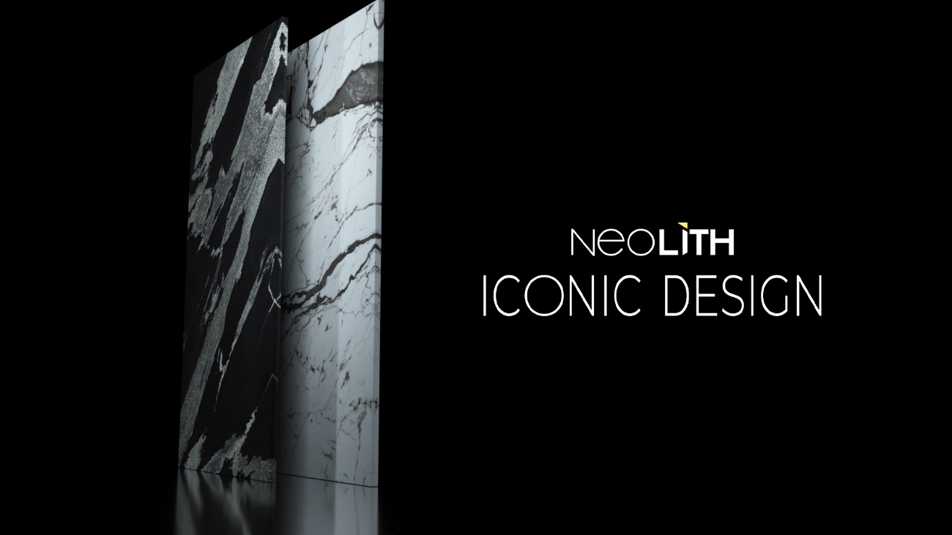

Patented Technology

Surfaces with impressive designs, zero limitations and the best technical properties are possible with the most cutting-edge technology. This in-house, patented and exclusive technology is the result of more than two years of diligent work in the R&D&I Department in response to the needs of sector professionals and consumer insights, now giving the brand the opportunity to offer architects and designers exclusive design tools so they may turn their creations into reality with no limits on their imaginations.

It reflects a major commitment to 100% real 3D decorating, which enables the use of brighter colors and greater depth. It also opens the doors to new textures offering a number of possibilities never before imagined in this industry. The new development is of great value particularly for kitchen and bathroom countertops.

This ambitious project, which was supported with heavy investment of more than three million euros, is backed by the CDTI (Spanish Center for Industrial Technological Development) and is part of Neolith’s industrial expansion plan. The project has allowed it to create a patent family as well as sign several collaboration agreements with various first-rate international technology partners, all in line with the company’s strategic plans to always be equipped with the most up-to-date technological advances and successfully implement them.

Sustainable 3D with free crystalline silica in the formula

On the cutting edge of design, technology and sustainability, Neolith is manufactured in a carbon neutral environment. The company’s constant commitment along with Neolith’s sustainable DNA have led it to now becoming one of the most environmentally-friendly materials available, inspiring new architectural trends.

With the launch of Neolith Iconic Design, Neolith is at the forefront of innovation upon presenting a surface that’s unique in composition and appearance. Based on a new formula, Neolith Iconic Design has a 0% of free crystalline silica, which is completely revolutionary as the lowest percentage in the industry to date.

Moreover, 100% of the energy used for the production of this new generation of surfaces comes from renewable sources, and all the water used in the process is recycled. This new manufacturing, patent and certification process meets one of the great demands in the market, thus creating new opportunities for design and application in addition to simplifying the installation work.

About Neolith
Fully believing in the idea that “the best thing about creating something is living it”, Neolith is the global leader in sintered stone. A pioneering architectural surface with superior technical characteristics made of 100% all-natural raw materials, it can provide indoor and outdoor solutions. All around the world, it has become an essential style element for any kitchen, bathroom, facade, floor and even exclusive designer furnishings.
The virtues of Neolith sintered stone combine next-generation technology featuring impressive no-limits designs through its Iconic Design line and high functionality. All of that, along with Neolith’s sustainable DNA, have led it to becoming one of the most environmentally friendly materials on the planet as it advocates sustainable beauty in all of its collections to inspire new trends in architecture.
The company is currently immersed in an expansion plan aimed at key geographic areas such as North America, Australia, the UK, Europe and China in order to continue contributing to the creation of unique spaces and extraordinary experiences featuring sustainable functional design in the nearly 100 countries where it is present through direct distribution as well as an extensive sales and partner network.

