Neolith Earns the EcoVadis Gold Medal Rating for Sustainability, Positioning It in the Excellence Segment of the Industry

- With this certification, Neolith Group is now officially recognized for its incredible sustainability performance, ranking it as one of the highest valued companies in the sector.

- This rating places Neolith in the 97th percentile of the industry and corroborates the fact that it operates with excellence.

- EcoVadis, the most credible sustainability index worldwide, assesses companies’ corporate policies, initiatives and business achievements in environmental, labor and human rights matters as well as ethics and sustainable procurement.

Madrid; March 16, 2023 - Neolith, the global leader in sintered stone which is on the cutting edge of sustainability, design and innovation, has earned gold certification from EcoVadis, the most credible sustainability index in the world, which positions it among the most highly valued companies in the sector. This classification is the result of the firm sustainability strategy Neolith has been carrying out.
By earning this certification, Neolith has renewed and improved the score it received last year as it is now positioned at the 97th percentile of the industry which reaffirms it is operating in the excellent segment of its sector in terms of its environmental, social, sustainable procurement, corporate governance and ethics commitments.
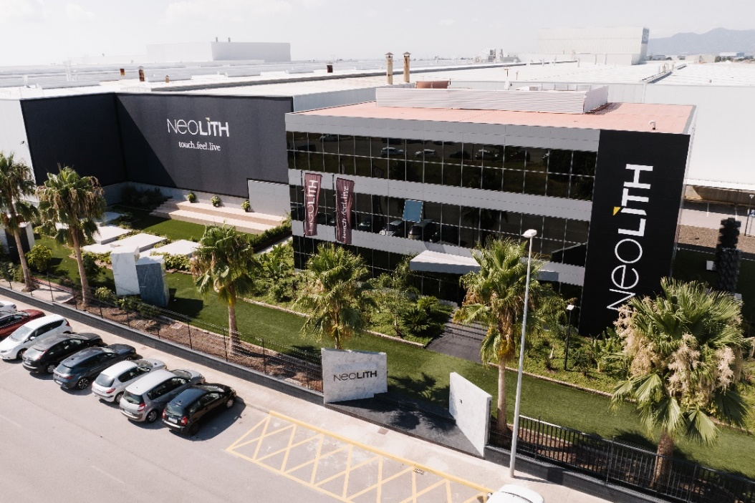
For Neolith, this certification offers significant added value as it provides precise guidance on the company’s strengths in order to focus its sustainability efforts. Moreover, it solidifies its engagement with sustainable development upon being recognized as one of the most reliable architectural surface solutions in the world by a company that scores the environmental, social and ethics performance of more than 100,000 businesses operating in over 200 sectors in 175 different countries.
For José Luis Ramón, CEO of Neolith Group, “From the very beginning of our origins, sustainability has been a part of Neolith’s DNA. Earning EcoVadis Gold certification once again makes our commitment to the value chain quite clear and obviously demonstrates we’re on the right path,” he says.
On the other hand, Francisco Mateu, Sustainability Manager at Neolith Group, mentioned that “We’re absolutely confident this certification will mean a boost for the company. It corroborates all the work we’ve been doing for years to attain unique levels of excellence in the industry, and that’s the reason why more and more national and international authorities are working and collaborating with us on a number of different types of projects. We’ve no doubt developed a culture with a sustainable mentality that influences the decisions we make within each team.”
EcoVadis Gold certification
EcoVadis provides companies with a sustainability ratings service through a global platform. The EcoVadis rating covers a broad range of non-financial management systems including environmental, labor and human rights, ethics and sustainable procurement impacts. Each company is rated on the material issues in accordance with their company’s size, location and sector.
The global EcoVadis rating (0-100) reflects the quality of a company’s sustainability management system at the time of assessment. The EcoVadis sustainability levels are based on a company’s percentile score in EcoVadis with the medal criteria reviewed periodically. A gold medal means the company is one of only 5% that have earned such a high score.
Efforts in innovation and sustainability
This constant commitment to sustainability has led Neolith to becoming one of the most environmentally-friendly materials available today, inspiring new architectural trends. To this end, Neolith is a revolutionary and innovative architectural surface with superior technical characteristics made of 100% all-natural raw materials.
Sustainability and corporate social responsibility have guided Neolith Group’s business activities from the very beginning. In addition to being certified under some of the most demanding requirements, the company develops all sorts of initiatives aimed at reducing and compensating its carbon footprint, using green energy and achieving energy self-sufficiency, boosting the circular economy, working with sustainable suppliers, being a transparent company and demonstrating excellence in labor practices and human rights.
On the cutting edge of sustainability, Neolith Group engages in a number of initiatives in this area as explained in its annual sustainability report which can be found at its official website www.neolith.com.
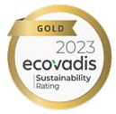

About Neolith
Fully believing in the idea that “the best thing about creating something is living it”, Neolith is the global leader in sintered stone. A pioneering architectural surface with superior technical characteristics made of 100% all-natural raw materials, it can provide indoor and outdoor solutions. All around the world, it has become an essential style element for any kitchen, bathroom, facade, floor and even exclusive designer furnishings.
The virtues of Neolith sintered stone combine next-generation technology featuring impressive no-limits designs through its Iconic Design line and high functionality. All of that, along with Neolith’s sustainable DNA, have led it to becoming one of the most environmentally-friendly materials on the planet as it advocates sustainable beauty in all of its collections to inspire new trends in architecture.
The company is currently immersed in an expansion plan aimed at key geographic areas such as North America, Australia, the UK, Europe and China in order to continue contributing to the creation of unique spaces and extraordinary experiences featuring sustainable functional design in the nearly 100 countries where it is present through direct distribution as well as an extensive sales and partner network.

